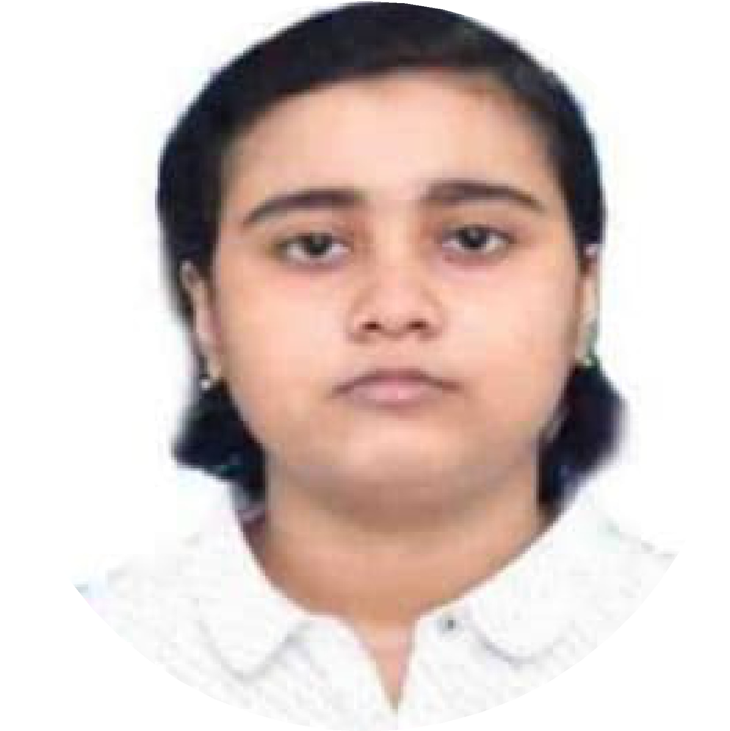TULIKA CHATTERJEE

[tulika15082002@gmail.com  +919330040193  Kolkata, India  [tulika-portfolio.vercel.app](https://tulika-portfolio.vercel.app/) [tulika-c-88910121a  [@tulika1508](https://twitter.com/%40tulika1508)](https://linkedin.com/in/tulika-c-88910121a)](mailto:tulika15082002@gmail.com)



# EDUCATION

## B.Tech in Information Technology

### IIEST,Shibpur

 Dec 2021 - June 2025 (expected)

* CGPA (Till 7th semester): 8.86/10.0
* Relevant coursework: Data structures, Operating systems, DBMS, OOPs.

# WORK EXPERIENCE

## Frontend Developer Intern

### [SiteMaster](https://www.sitemaster.ai/)

 May 2024 – July 2024  Kolkata, India

* Optimized web application responsiveness by implementing media queries; enhanced user experience, reduced bounce rate by 10%.
* Developed a dynamic and responsive search and filtering panel, leveraging state management, improving UI/UX.
* Rectified over 10 bugs and upgraded key features, such as task management and project dashboard fetching data from APIs.

## Software Tester

### [SiteMaster](https://www.sitemaster.ai/)

 April 2024 – May 2024  Kolkata, India

* Delivered solutions by implementing manual testing method- ologies in process improvement initiatives, resulting in reduc- tion of defects.
* Designed over 50 test scenarios and test cases for the mo- bile application’s Finance, Task Management, and Worker Management.

# MENTORSHIP EXPERIENCE

## Mentee - Women in Tech

### NXP Semiconductors

 Oct 2022 – Dec 2023  Hybrid, India

* Completed an intensive training program focused on pro- gramming languages, verilog programming, and digital sub- jects.
* Gained proficiency in C programming and Object-Oriented Programming (OOPs) principles.
* Implemented a robust 8b/10b Encoder Decoder project in Verilog.
* Gained knowledge about NXP’s values, culture, and cutting- edge technologies in the site visit.

# PROJECTS

## XMovies - Movie streaming platform

* ReactJs, Redux-toolkit, TailwindCSS
* Implemented secure user login and signup with Firebase authentication.
* Fetched the movies from TMDb API and incorporated fea- tures like segmentation of shows according to genre.
* Added slider feature to slide through the shows and made separate pages for movie and television shows.

[Github](https://github.com/tulika1508/XMovies-frontend) [Site](https://xmovies-frontend.vercel.app/)

## Inkyy-Real Time Collaborative Whiteboard Web App

* ReactJs, NodeJs, Socket.IO
* Developed a collaborative whiteboard sharing web applica- tion with real-time updates.
* Incorporated features like notification on user entry and exit

using React toastify, total participant list.

* Added undo, redo and clear board features and generating

unique room id for every meeting. [Github](https://github.com/tulika1508/Inkyy)

# ACHIEVEMENTS

* NXP WIT Scholar 2022: One of the top 50 students (in In- dia) selected in the Semiconductor Cohort by NXP Semicon- ductors.
* CURIOSITY Coding Competition 2023: Secured 5th position in the IT departmental coding competition.
* ZS Tech Challenge: My team "StackOverFlow" secured a position within top 125 teams.
* Open Source: Selected as a contributor in GirlScript Summer of Code 2024 and Social Summer of Code 2024.

# TECHNICAL SKILLS

* LANGUAGES: C, C++
* WEB DEVELOPMENT: HTML, CSS, Javascript,

React.js, Node.js.

# EXTRA-CURRICULAR

* Millennium Campus Network Fellow(Class of 2023)-Working on the project "The Green Horizon" to promote sustainability in campus.
* Received Sangeet Bhusan in Rabindra Sangeet and Classical Singing(2nd year).
* Hobbies-Blog writing, Gardening.